Long Division of Polynomials  Quiz | Name:  Date:

- 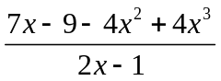

- 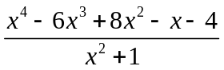

- 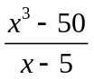

SELF-REFLECTION ACTIVITY

- Which segment of the long division of polynomials was most challenging for you?

- What steps are you going to take to learn this subject?

